

American International University-Bangladesh (AIUB)

**Department of Computer Science**

**Faculty of Science &Technology (FST)**

**Spring 2020-2021**

**CSC 2210 Object Oriented Analysis and Design (OOAD)**

**Section: K  
Group No: 4**

**“Convenient E-Ticket Store”**

An Object-Oriented Analysis and Design (OOAD) project submitted

By

|  |  |  |  |
| --- | --- | --- | --- |
| SL No | Student Name | Student ID | Contribution |
| 01. | Md.Raihanul Islam Rafi | 19-41790-3 | 20% |
| 02. | Fardin Rahman | 19-41789-3 | 20% |
| 03. | Mehenaz Tabassoom | 19-41398-3 | 20% |
| 04. | Mushfiq Anjum Rafi | 19-41757-3 | 20% |
| 05. | Aditi Bhattacharjee Tumpa | 19-41693-3 | 20% |

**CHAPTER 1: PROBLEM DOMAIN**

**Project Background Analysis**

* Write the background description that helps putting the project into the right context of a problem domain and gives everyone involved a common view of the project
* Our application is made for avoiding crowd and to help maintaining self-distance. People from our country need to do their job to live their life, As It's necessary to go outside for people to attend their works but also need to avoid the crowd, this project is a best solution for them. It's also time saving and also avoid the crowd.
* What is the root cause of this problem? Why is this problem is so important to consider?
* The root cause of the problem is avoiding the crowd and saving time. Because, in this pandemic situation everyone needs to keep distance and also need to join at their respective work places. As day by day the situation is getting worst and it's not safe to standing in a line to collect ticket as before, this option is best for them to collect ticket. They can also take packages by their choice. This also saves money and time.

**Project Solution and Feasibility Analysis**

* What are the solutions you are going to propose to deal with the problem? Why this   
   solution is particularly appropriate to solve the problem? Is the solution feasible to the   
   meet the business objective?
* The solutions we are going to propose to deal with the problems are: 1. Avoid crowd; 2. Time consume; 3. Save money.
* People stand in a line for tickets and it's not safe for them in this situation, so we are providing tickets through online. People can buy tickets from anywhere and its time saving. And at this situation, many people are hardly saving money so we give them many offers to save money.
* No, the solution is not feasible to the meet the business objective because we make the application by thinking people's wellbeing at this pandemic situation.
* Provide a short description of the software being specified and its purpose, including relevant benefits, objectives, and goals
* The software is being specified for time consuming, avoiding crowd and saving money. Its purpose is to providing facilities to customer without going anywhere. The benefits of this software are customer getting facilities and we can make little money from it. The objective or goal is improving the system more and more for the customer and make it best online-platform for buying tickets.
* Existing studies presented in the problem area. What are the existing software solutions   
   are available to solve the aforementioned problem?
* What makes this project new, innovative, interesting, or otherwise distinct from other similar projects? Does the project duplicate functionality already available in the market?
* As people are deepening online-platform day by day, it’s a greatest chance they can grab. Because of this is a new platform with many facilities customers find it easy and interesting. The project is innovative because its helps to get facilities at any situation at any place. The project is distinct from other similar projects because it shows current condition of the roads and bus current location, time of travelling. No, there are no the project duplicate functionality already available in the market.

**Scenario:**

Convenient E-Ticket store which, is an online e-ticket service where a ticket buyer can get services in four criteria those are; i) standard class, ii) Student class, iii) business class, iv) premium class. Customer has to log in with id & password in the application. If the id & password incorrect then system will display login error, and user have to log in again. There ID will store the billing information, location, time and destination. In the service, Free Wi-Fi will be provided to all kinds of users. A Standard class user can get maximum 2 tickets & also can get discount depends on their usage. A student class user can get 5 tickets in maximum and can get half-pass facility. A business class user can get maximum 20/25 tickets at once, will get real time bus information and snacks. A premium class user can get unlimited tickets and will real time bus information and one meal through the journey. The system will give excess to the genuine user and will allow them to get tickets according to bus schedule and available sits. Users will pay the money through cards or bank account and in the end, system will check whether the payment have been successfully completed or not and system will send confirmation to users. If the user doesn’t pay within due time then the booking will be automatically cancelled.

**CHAPTER 2: UML DIAGRAM**

## 2.1 Use Case Diagram

* + Does the use case narrative represent the Scenario of the use case diagram?
* Yes, it represents the Scenario of the use case diagram.
  + Does the Use Case diagram include the major use cases, actors who perform the use cases and the relationships among the use cases needed to deliver by the system?
* Yes, it includes the major use cases, actors who perform the use cases and the relationships among the use cases needed to deliver by the system.

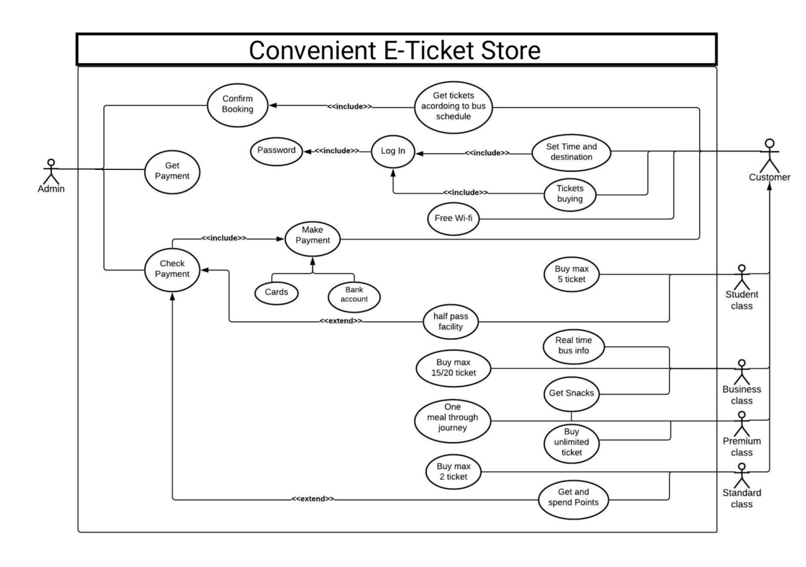

## 2.2 Class Diagram

* + Does the class narrative represent the Scenario of the class diagram?
* Yes, the class narrative represents the Scenario of the class diagram.
* Does the Class diagram include the major classes (attributes, operations) and the relationship among the classes needed to deliver by the system?
* Yes, the Class Diagram includes the major classes; those are customer, Payment, Buy ticket, Confirmation and they also make relationship among the classes needed to deliver by the system.

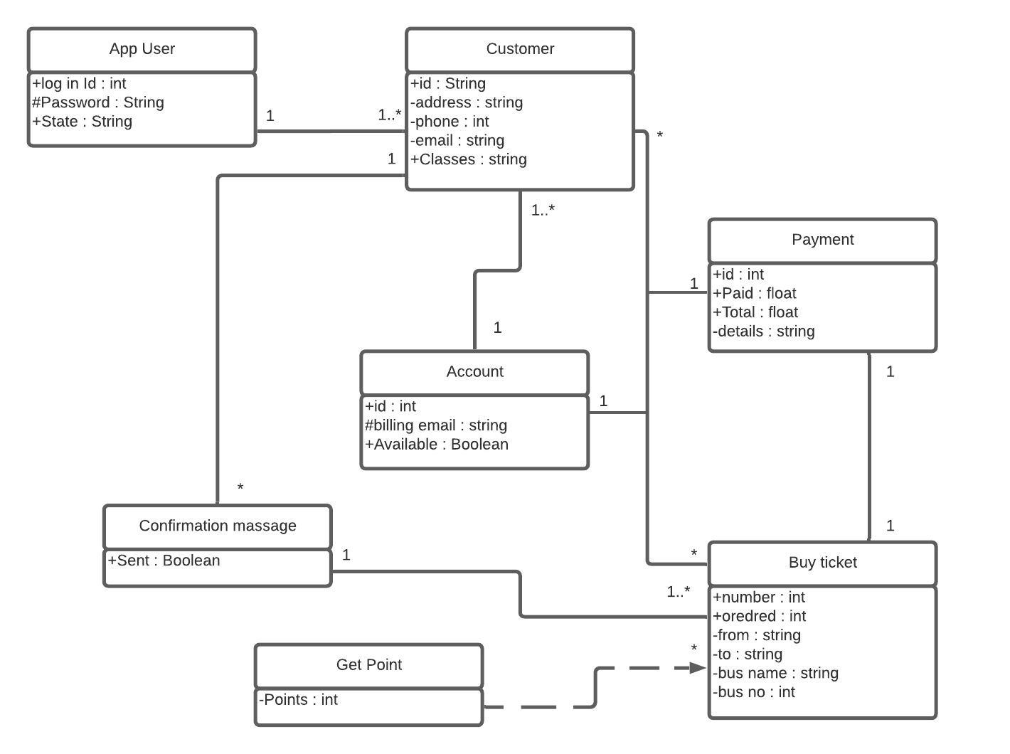

**2.3 Sequence Diagram**

* Does the sequence narrative represent the Scenario of the sequence diagram?
* Yes, the sequence narrative represents the Scenario of the sequence diagram.
* Does the Sequence diagram include the sequence of the major activities needed to deliver by the system?
* Yes, the Sequence diagram include the sequence of the major activities needed to deliver by the system

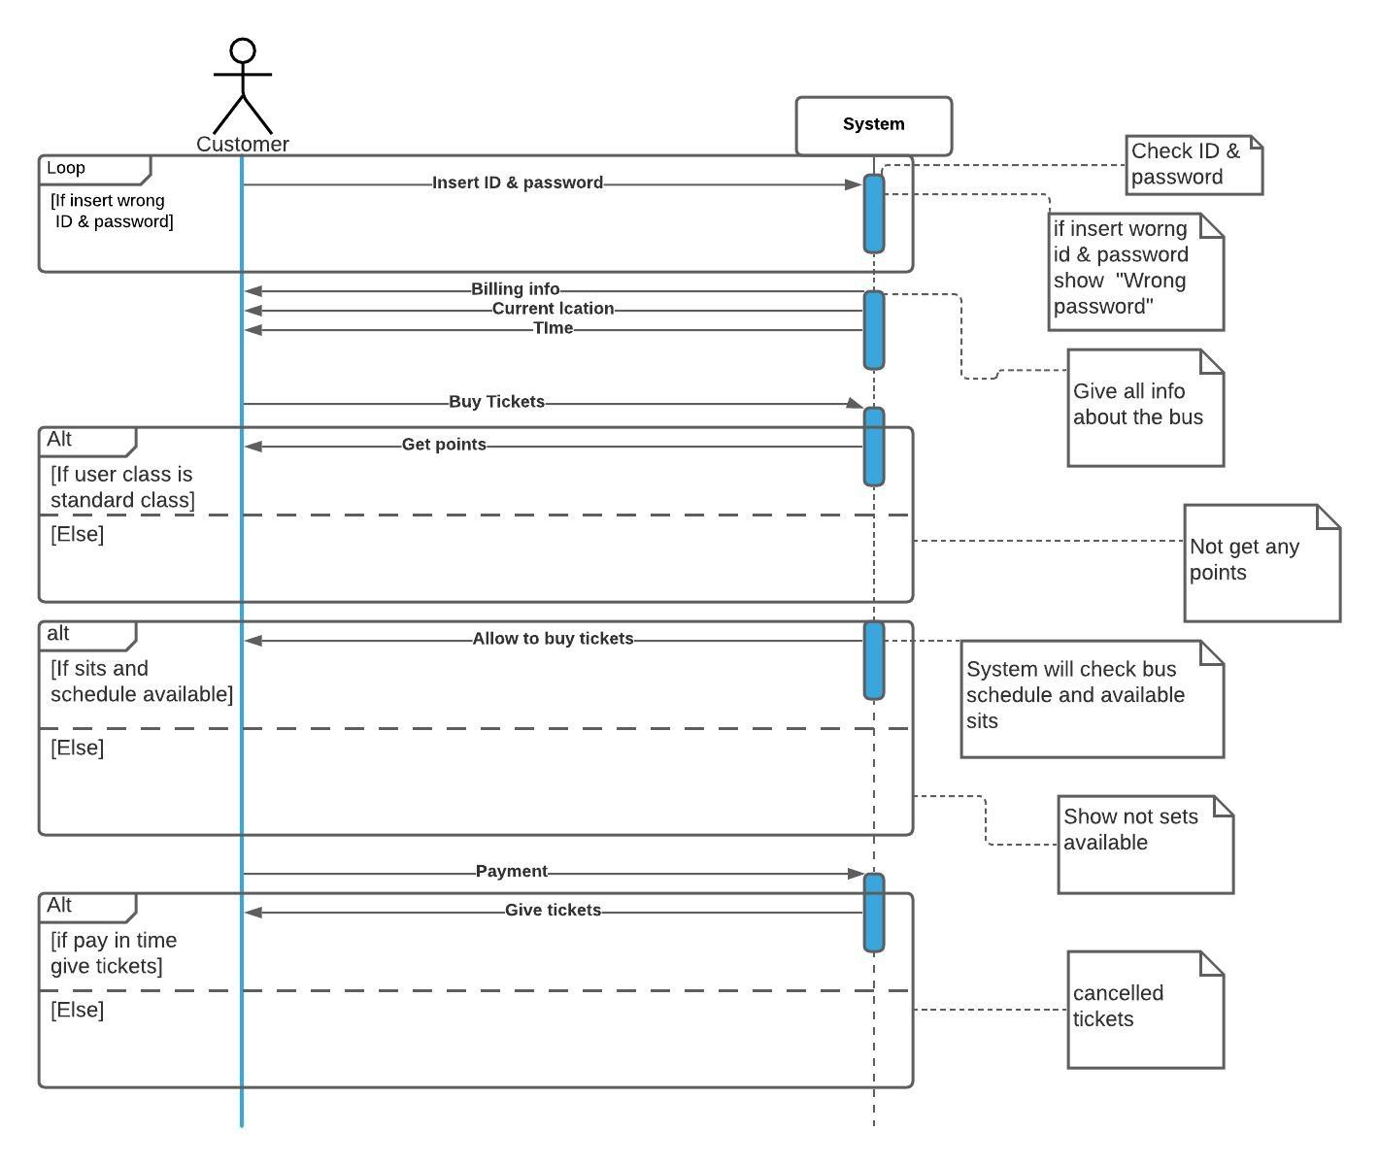

## 2.4 State chart Diagram

* + Does the state chart narrative represent the Scenario of the state chart diagram?
* Yes, the state chart narrative represents the Scenario of the state chart diagram.
* Does the State chart diagram include the major states needed to deliver by the system?
* Yes, the State chart diagram includes the major states needed to deliver by the system.

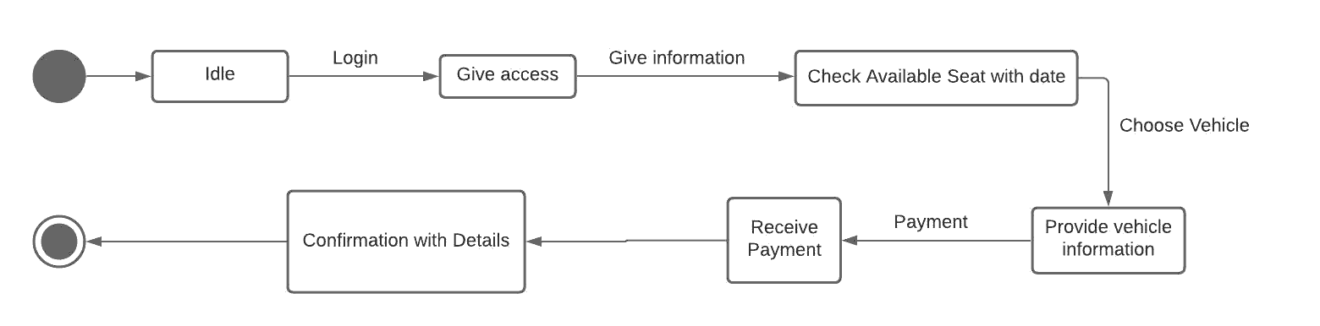

**2.5 Activity Diagram**

* + Does the activity narrative represent the Scenario of the activity diagram?
* Yes, the activity narrative represents the Scenario of the activity diagram.
* Does the Activity diagram include the major activities needed to deliver by the system?
* Yes, the Activity diagram includes the major activities needed to deliver by the system.

